EDA ( (E xploratory
Data Analysis)

WEEK -8

REPORT

SUBMITTED BY :

- SAHANAA SREE
E25DA045

Problem Statement :
To analyze student performance data in Power BI by calculating total and average marks and categorizing students based on their performance.

Objective :

. To create an interactive dashboard that displays students' aveon academic performance.rage scores, pass percentage, performance grades, and the impact of various factors

Tasks and Deliverables :

- Cleaned and transformed student data using Power Query.

- Created calculated columns for total marks, average, performance grade, and results.
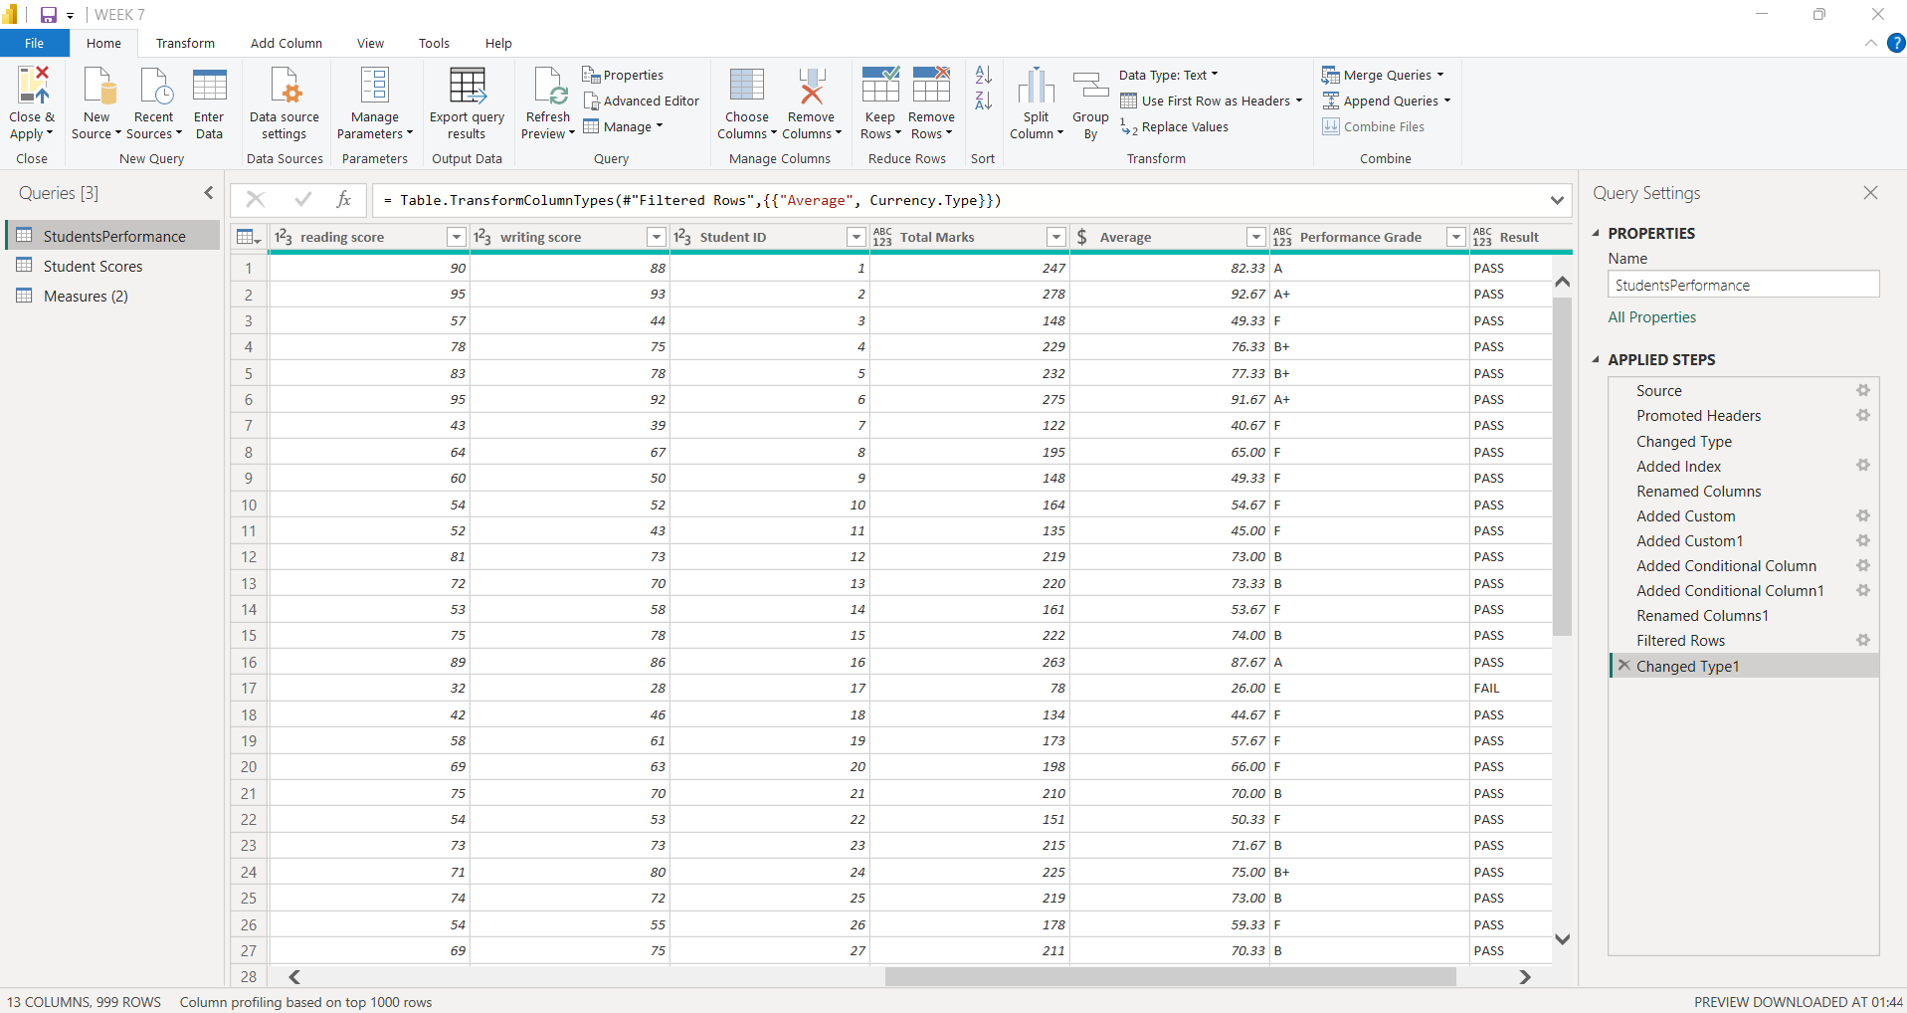

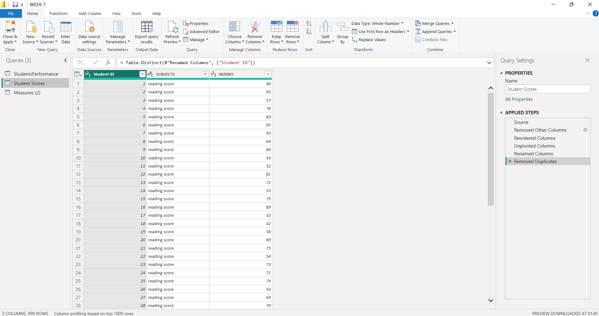

. Analyzed student scores based on gender, lunch type, parental education, and test preparation.

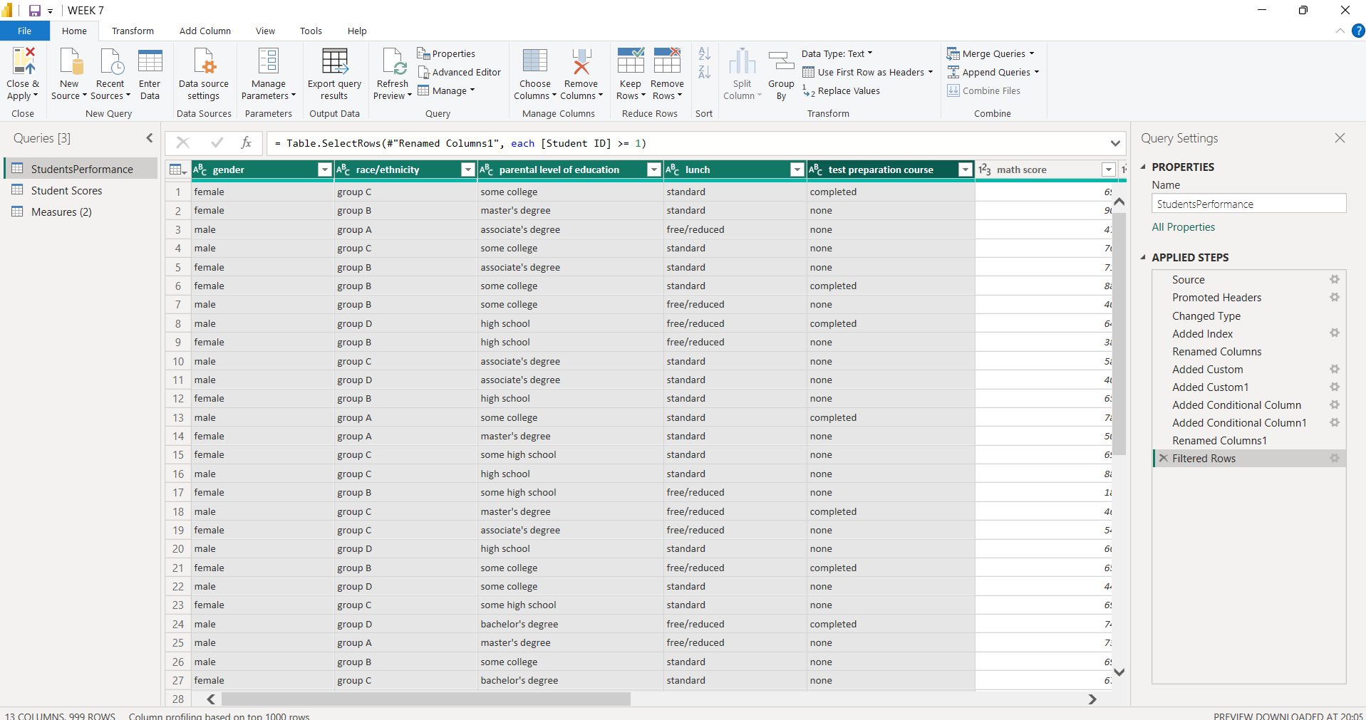

. Designed interactive dashboards using
charts, cards, and slicers.

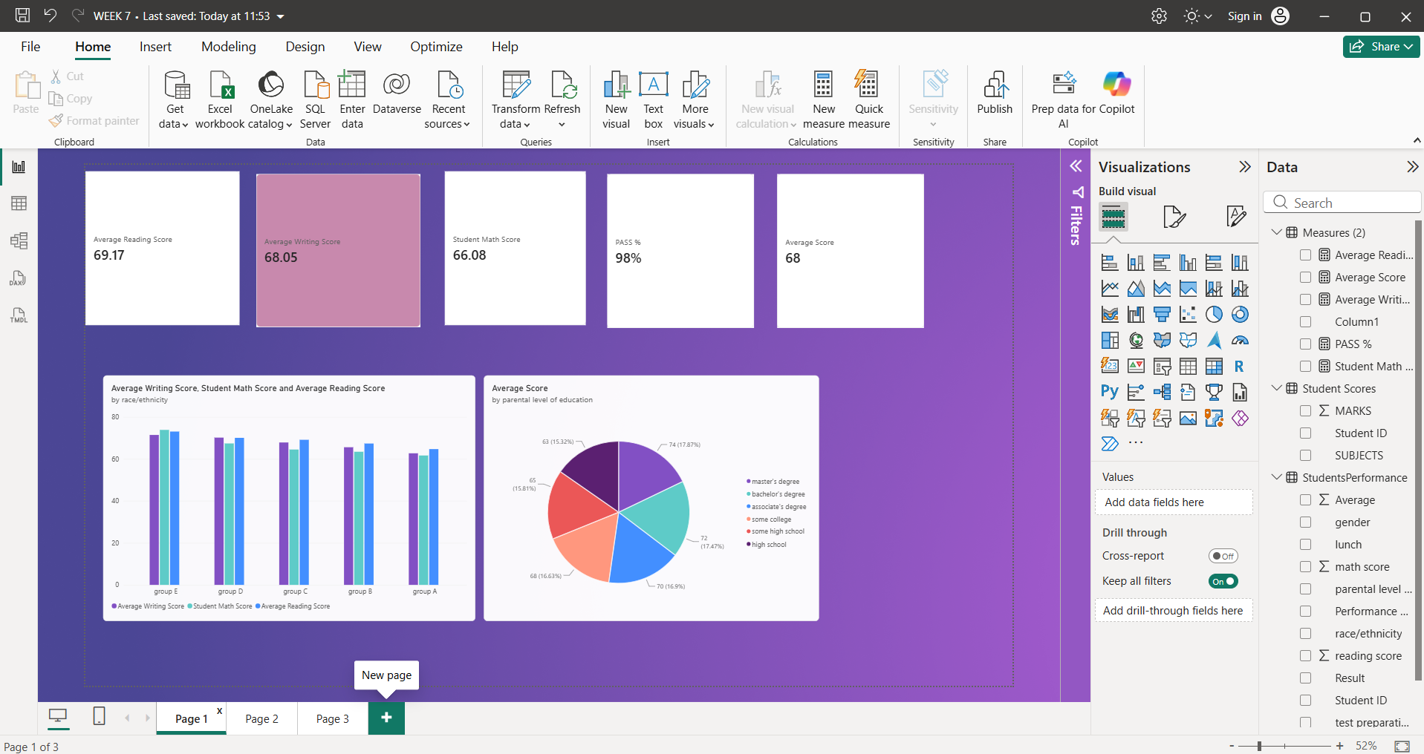

. Displayed key performance indicators,
including average scores and pass percentage.

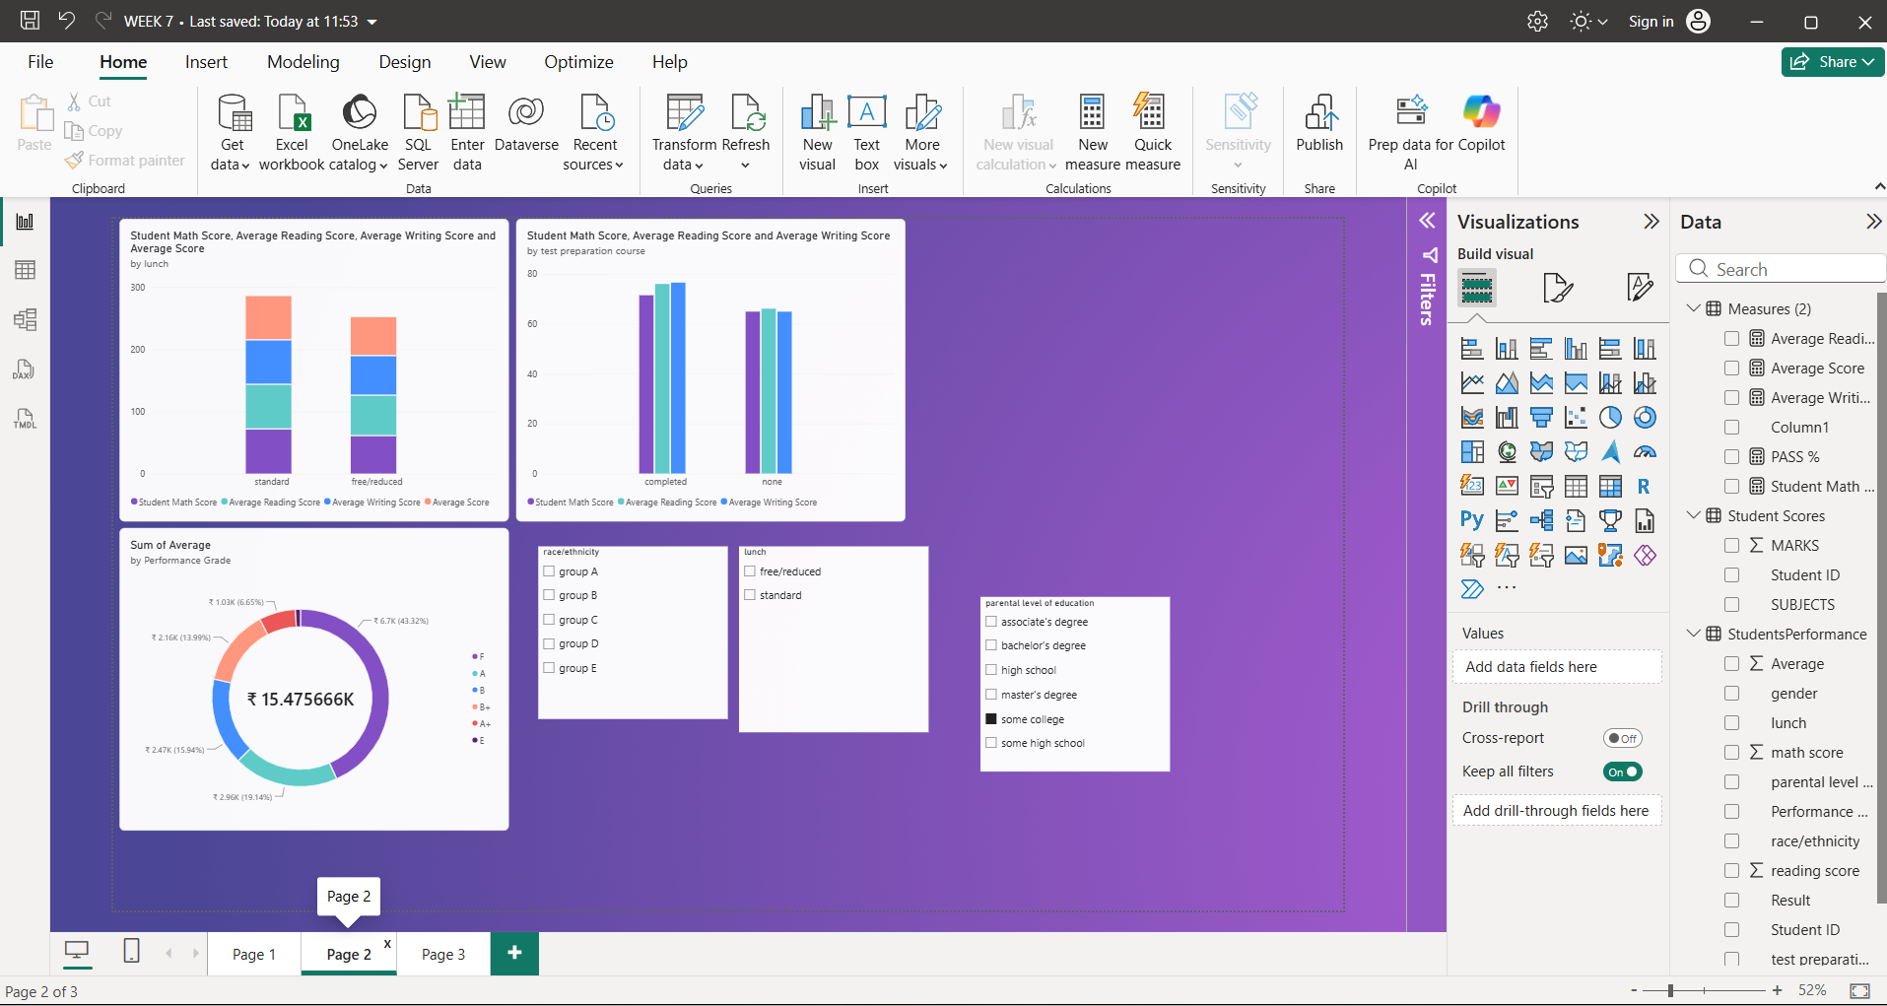

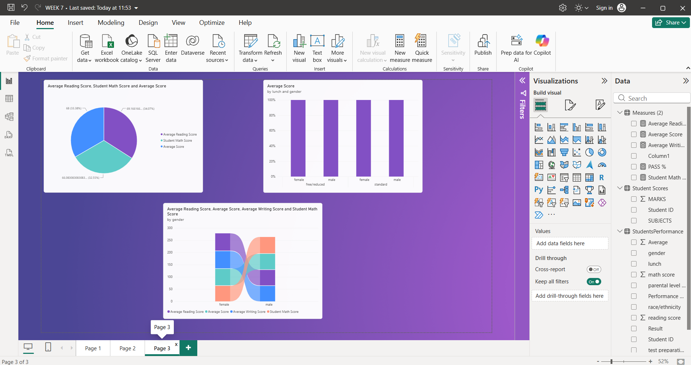

OVER ALL ALL DASHBOARDS :

Conclusion :

The Power BI dashboard provides a clear view of student academic performance. It helps compare scores across different categories and identify factors that may influence students' results.

